Freightnet International (Vic) Pty Ltd
9c International Square. Tullamarine
Victoria. 3043. Australia . TEL: +613 9335 4511 Website : www.freightnet.com.au
Personal Effects Acceptance Questionnaire

Please indicate if ANY of the following items are included in your shipment (must indicate YES or NO)
1- Fireworks, ammunition - sporting ammunition, firearms or explosives YES NO
2- Cylinders of compressed air, oxygen, or liquid petroleum gas (LPG) any type of YES NO
aerosol can, (eg deodorant, shaving cream, hairspray , paint etc…)
3- Camping stoves, cigarette / pipe lighters or cigarette lighter refills YES NO
4- Nail polish, colognes, perfumes, paint, fuel or paint thinners YES NO
5- Matches YES NO
6- Dry ice, specimens or samples YES NO
7- Detergents, bleaches, drain or oven cleaners YES NO
8- Fiberglass repair kits, adhesives and puncture repair kits YES NO
9- Alcohol (ie whiskey or wine) , medicines containing alcohol YES NO
10- Any types of chemicals, pesticides, herbicides etc… YES NO
11- Computer / laptop / mobile phone / i pad or tablet ? YES NO
12- Diving equipment YES NO
13- Machinery with internal combustion engines such as chainsaws, lawnmowers, YES NO
garden trimmers

Please note: Under Part 23 of the Australian Civil Aviation Act (1988),and under the Laws which govern the transport of baggage and cargo worldwide, heavy penalties including imprisonment apply to shippers who do not declare dangerous goods in any item consigned to an airline.

Date :
Shipper name :

Shipper signature :

*** Most Important - Goods are sent to airport only.
All charges upon arrival at destination airport will be payable by receiver ***

Some examples of what your shipment MUST NOT contain :

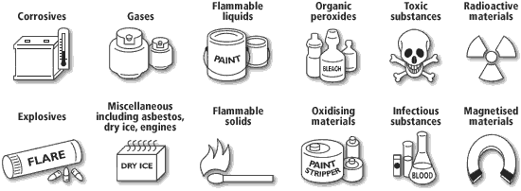

AIR - AVIATION SECURITY
Airfreight will be subjected to security and clearing procedures
It is illegal to consign unauthorised explosives or incendiary devices as airfreight

