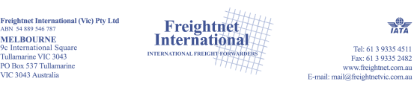

SOLAS VGM FOR LCL CARGO
New regulation changes in Safety of Life at Sea (SOLAS) in regards to the Verified Gross Mass (VGM) that became effective as of July 1st 2016. Freightnet takes safety and compliance of relevant regulations seriously and the following is an outline of how we will handle the VGM requirements in regards to Less than Container Load (LCL) cargo.
The VGM regulation requires that every container that is loaded onto a ship engaged in an international voyage must have a declared VGM. The VGM includes the entire packed container (including any packing materials, as well as cargo items).
The responsibility for declaring the VGM lies with the shipper, and in the FAK/LCL environment, Freightnet is the shipper of record on the Master Bill of Lading. Therefore, the responsibility for declaring VGM lies with us.

WHAT DO WE NEED FROM YOU?
- Freightnet will assume that the weight given for any given LCL shipment, as submitted to us, by you, is accurate.
- Weight for LCL shipments need to be submitted to Freightnet no later than the advertised LCL cut off date.
- We will accept weight information via the same method we do today, as part of the regular documentation flow accompanying the shipment.

Please remember that weight includes all packing materials – including pallets, if applicable.
Shipments upon receipt at our CFS will undergo VGM verification and they will supply confirmed verified gross mass weight

